Pokémon Decades

Decades in a Gen 9 Legends ZA fan game, in the Gen 4 art style featuring all Battle Gimmicks and Pokémon through Generation 9, including nearly every Battle Mechanic content throughout the series, such as Hidden Power. Collect, train and battle with all 1025+ Species available in-game and take on the 18 Type Masters, to prepare yourself for defeating the world ending power, contained within the Zenith Domain.

Welcome to Beatha
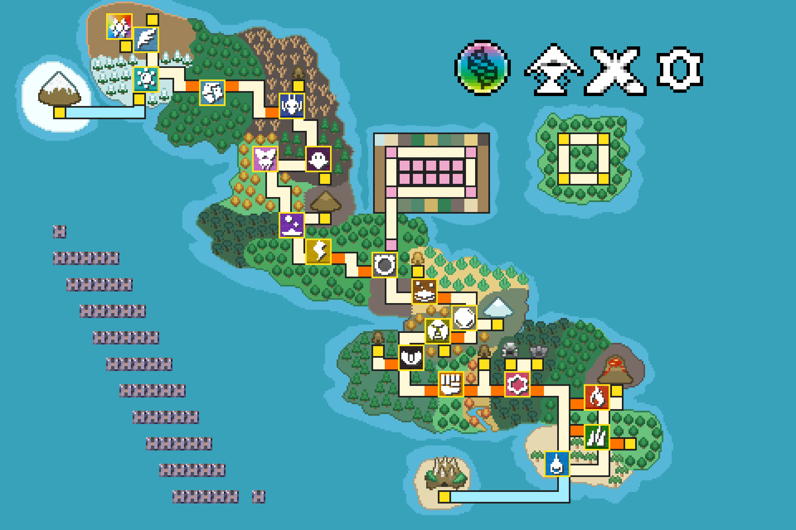
Beatha Region (Full Finished 3.0.0 Map. 1 Region Game, 18 Type Masters, 1 Final Boss, 1 Super Boss, 51 Mystery Zones, Battle Paradise and the Safari Zone)
The Beatha Region is a place in the world of Pokémon, where the energy from the Region’s Type Emeralds creates land, overflowing with Pokémon from all around the world, from Kanto (Gen 1) to Paldea. (Gen 9) This energy also results in the phenomena of Mega Evolution, Z-Power, Dynamax and Terastallization roaming free across the Region.

Story Mode
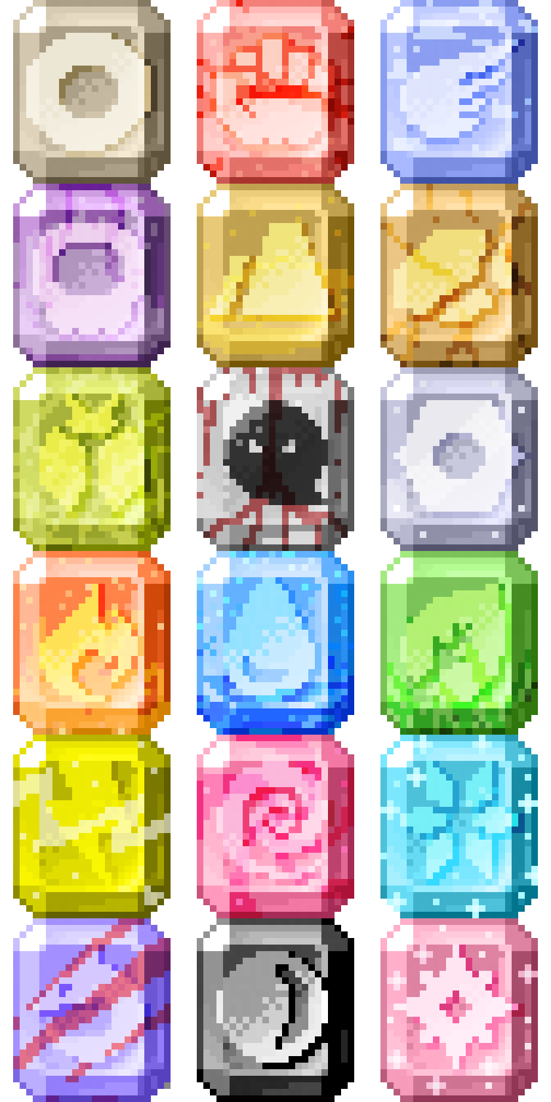
Tera-Type Icons Made Sol Emeralds by Sonicover https://eeveeexpo.com/resources/1139/
Your goal is simple. Collect all 18 Type Emeralds from Beatha’s Type Masters and defeat the power brewing in the Zenith Domain. If this power is not defeated, one day, it will break the seal on the Peninsula of Mastey and doom the world.

Battle Mode
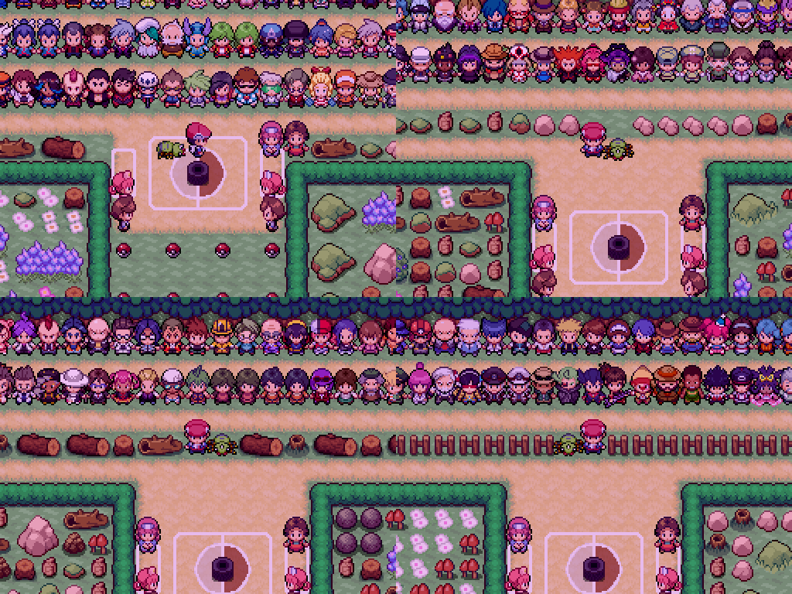
In this dedicated mode, you are fully free to experiment with Decade’s Gen 9 Metagame Sandbox. Battle over 438 Pokémon Trainers from around the world in Battle Paradise.
Fight in any Battle/Level Format you want. From Single, Double and Triple Battles to Smogon Cup, (Lvl.100) VGC Cup, (Lvl.50) NFE Cup, (Lvl.30, Not Fully Evolved) and Little Cup. (Lvl.5) Battle/Story Mode provides the player with the PSS (Pokémon Storage System) and Trainer Suites.

Features
Learn quicky through Decade’s extensive in-game documentation efforts – Metagame Wiki Dex, Adventure Guide, Type Matchups in Battle, (T Key in Battle) Type Chart Lookup, (Adventure Guide) and more
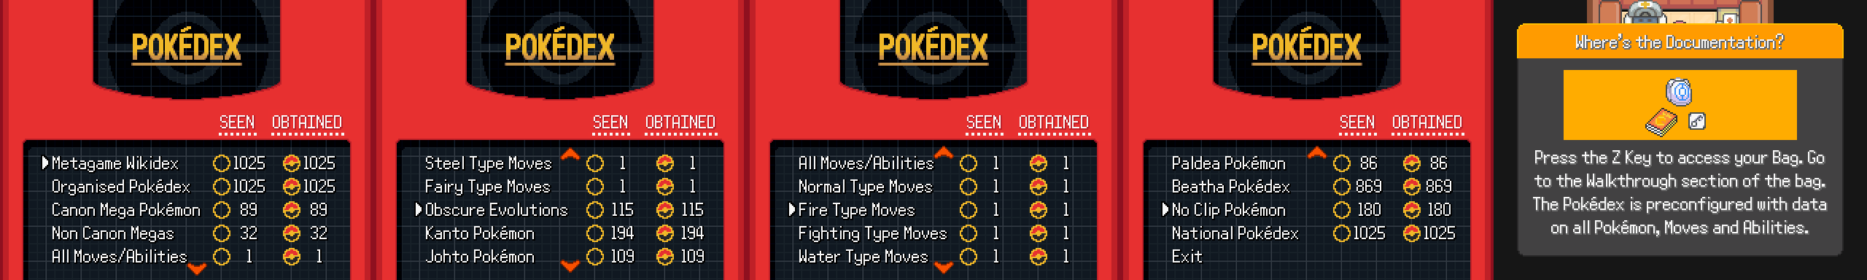
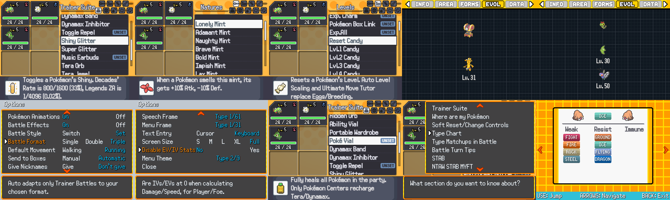
Jump right into the action that values your time through drastic and countless quality or life (QOL) features – EV/IV Allocator, Ultimate Move Tutor (Allows a Pokémon to learn through the Gen 9 Move Relearner System the entire history of their Learn Sets, from Gen 1 to Gen 9, Pre Legends ZA, including obscure Event moves, such as Octazooka Sableye, and Zap Cannon Squirtle. The All Moves Disk Key Item eliminates all error in Learn Sets not up to date with Legends ZA), PSS Exp Gain, PSS/Trainer Suite, Ability Vial, Hidden Orb for manual Hidden Power Types, DexNav, Instant Interactable Encounters, (Headbutt, Fishing, Rock Smash) Form Trader, Toggable Exp.All/Exp Charm Presets, 100% Wild Battle Flee Rate, No Gym Badge and Removable HM Field Moves, Fast Travel Phone, Toggle Repel, Shiny Glitter, Unlimited Nature Mints, Reset and Level Candies, Standarized Evolution Methods for all non-Obscure Evolution Pokémon, Delta Speed Up, Manual Battle Format in Options, Disable EV/IV Stats in Options, and the Poke Vial
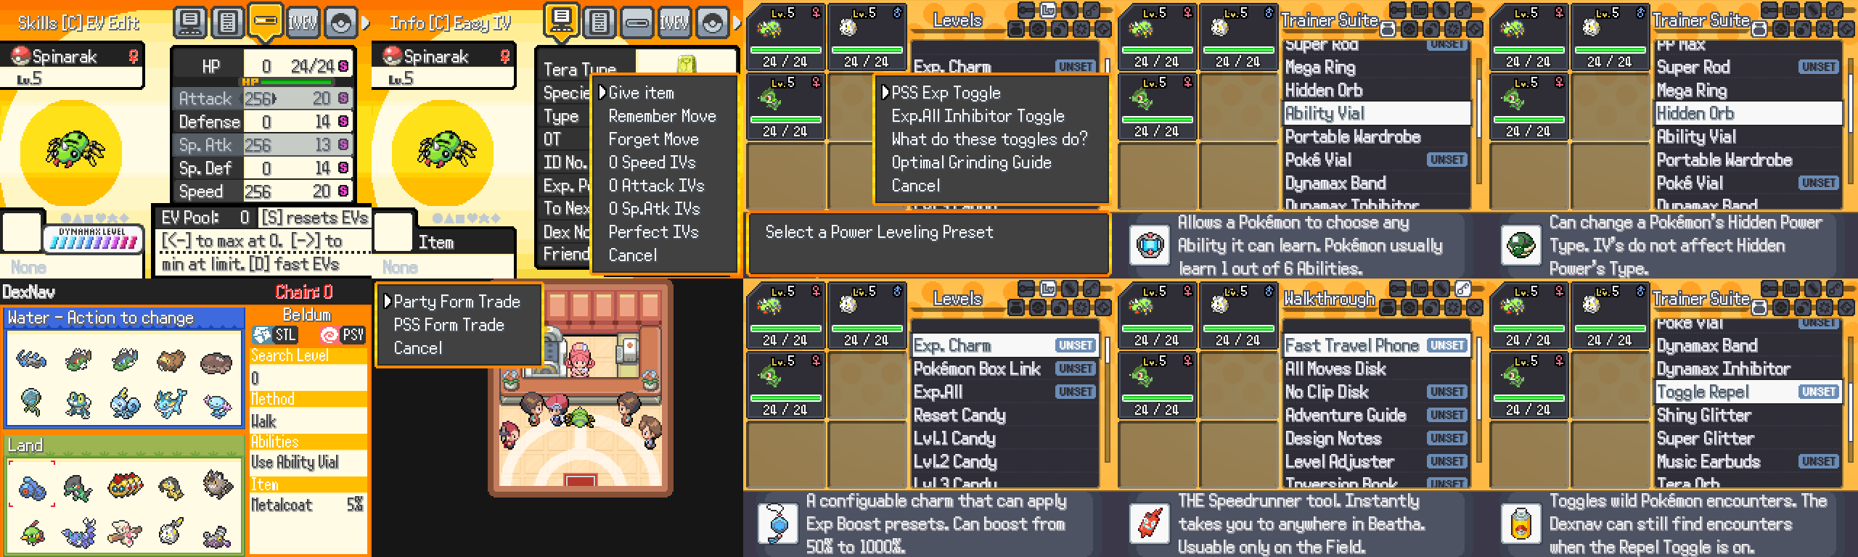

A Transformed Metagame
Directly inspired by the efforts of Tectonic, Decades, within the limits of being developed by only one person using public resources, has done all it can to replicate giving every Pokémon a fair shake in having a place on your team. Decades, by the nature of being developed by only one person, cannot reach the same heights as Tectonic and Rejuvenation in making every Pokémon viable. (The Rejuvenation Team, the group of people who have worked on Pokémon Rejuvenation for 10+ years ongoing, consists of 102 credited people, with 3 people dedicated to the job of Balancing. Pokémon Tectonics’ Team consists of 30 current members, 30 former team members, and countless credited Art team members. Every member credited as a Project Lead, QA Lead, General Developer, Designer, QA, Regional Forms Designer, Technical Designer, Programmer, Move Animator, Battle Design Lead, can be assumed to have done Balancing work)

NTAW STAB MYFT
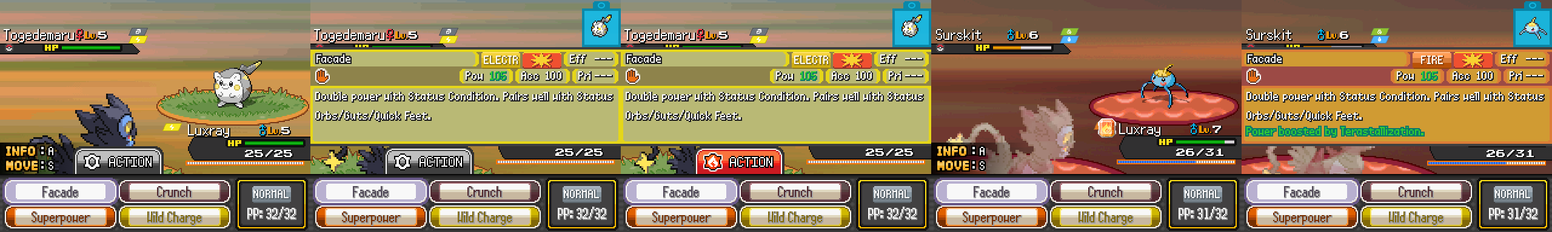
Normal Type Attacks Without Same Type Attack Bonus Match Your First/Tera Type, or NTAW STAB MYFT showcase. A Pokémon’s Primary/First Typing is what converts a Normal Type Move into a different Type. Universal for every Pokémon. Togedemaru would change Normal Type Moves into Steel Type Moves, Surskit would change Normal Type Moves into Bug Type Moves. The Type on top of the Type Icons in battles is what a Pokémon’s Primary Type is. Moves such as Soak can change non-Tera Pokémon Types)
Decades uses Normal Type Attacks Without Same Type Attack Bonus Match Your First/Tera Type, or NTAW STAB MYFT for short (I did not have a stroke while typing that, I swear). A mechanic that makes every Normal Type Attack auto adapt to any Pokémon’s Primary/Tera Type. This mechanic means a lot of Pokémon now have more viable Physical and Special Attacking moves to use, if their Type is lacking good Options (Flying Types lacking good Physical Flying Moves that are not Brave Bird, Rock Types lacking any good Special Rock Type Moves that are not Meteor Beam, Fairy Types lacking any accurate good Physical Fairy Types Moves that are not Play Rough, Electric Type lacking good Physical Electric Moves in general that are not Wild Charge or Supercell Slam, etc.)
A Raised Floor, a Lowered Ceiling Power Level
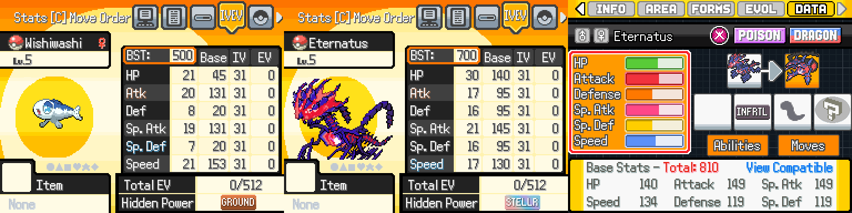
Lowest and Highest Base Stat Totals (Every Pokémon’s Base Stat Totals are in the ranges of 500, 550 and 600 BST. Every Special Case in the official games, such as the Scyther Line and more have been accounted for. Mega Pokémon still gain +100 to their non-HP BST. Arceus and Eternamax Eternatus are the highest BSTs at 810)
Decades applies a 500 (Stage 1 Pokémon), 550 (Stage 2 Pokémon) and 600 (Stage 3/Fully Evolved Pokémon) Base Stat Total standard for every Pokémon, with every special case accounted for, (The Scyther Line, etc.) and a slightly higher boost for the Pokémon that need it. (Onix, Tropius, etc.)
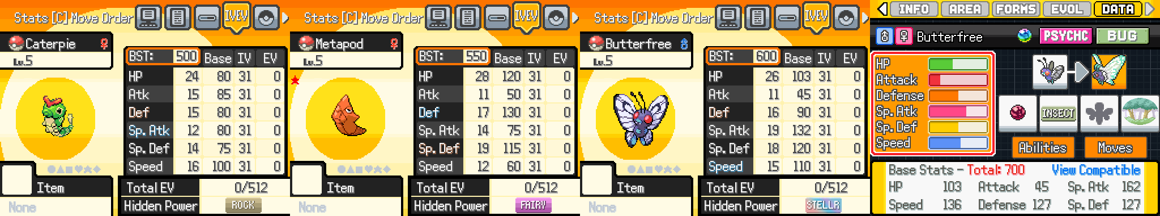
An average regular Stage 2 Pokémon’s Base Stat Total Family Line progression (Every Pokémon’s Base Stat Totals are in the ranges of 500, 550 and 600 BST)
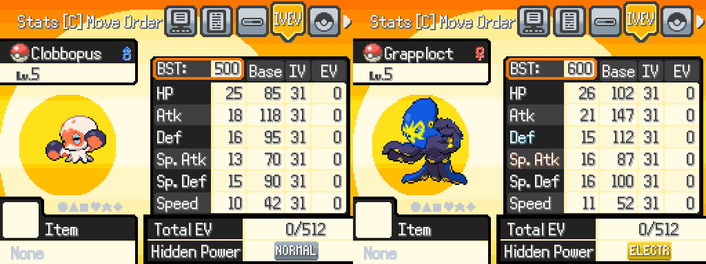
An average regular Stage 1 Pokémon’s Base Stat Total Family Line progression (Every non-Obscure Evolution Pokémon Family Lines Evolution Methods have been standardized. Stage 2 Pokémon Evolve at Level 30 and Level 50. Stage 1 Pokémon Evolve at Level 31)
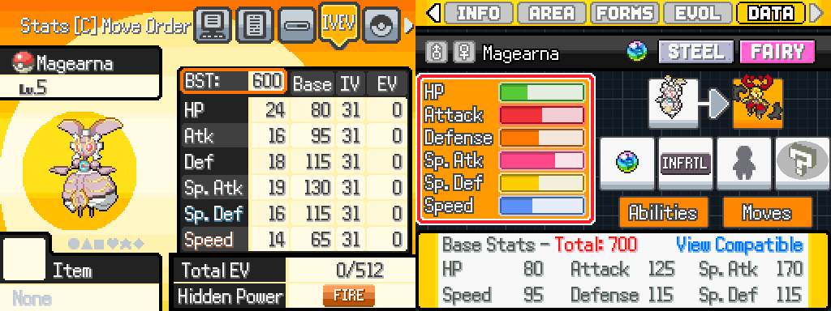
An average Legendary Pokémon’s Base Stat Total Family Line progression

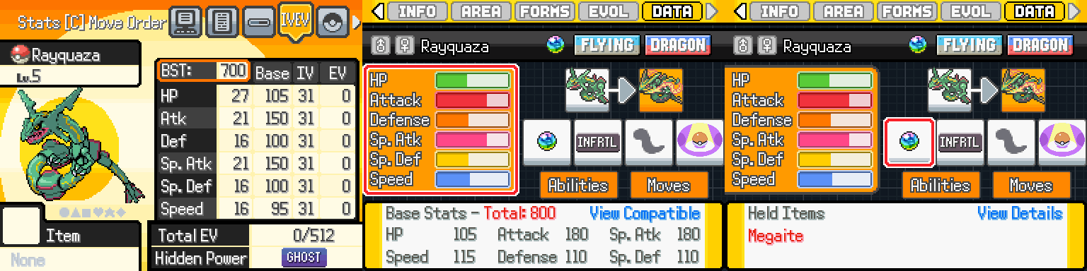
A strong Legendary Pokémon’s Base Stat Total Family Line progression (Rayquaza must hold the Megalite to Mega Evolve. This change ignores Rayquaza’s lore of having a natural Mega Evolving organ in its body. Megas break the game when they are not forced to hold onto only a Mega Stone to access their transformation)

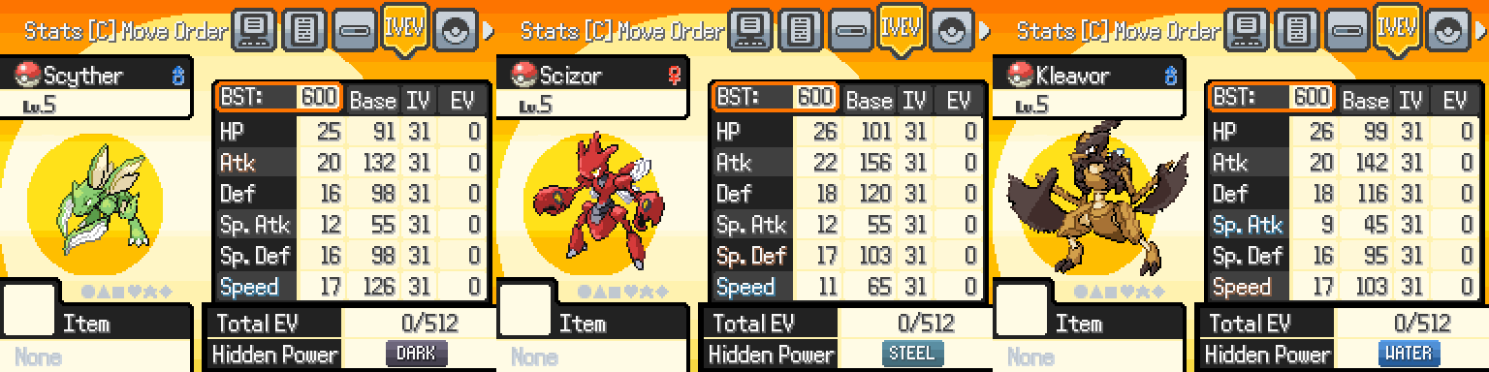
The first special case Pokémon Family Line (The Scyther Line all have the same BST in the official games, and every Pokémon Scyther Evolves into simply rearrange where the Base Stats are allocated)
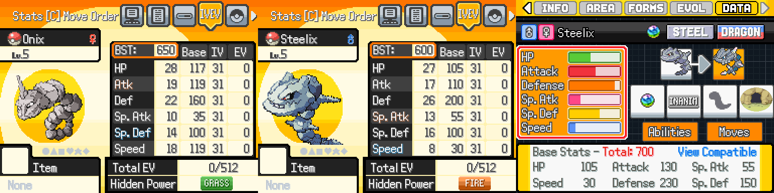
The second special case Pokémon Family Line (Onix is cursed in the official games from being designed as a tutorial on the fundamentals of Type Matchups in Generation 1. I wanted to allow them to be unchained from their canon 385 BST, that gives little to nothing for fixing the terrible distribution of their canon 385 BST. Steelix reverting to 600 BST is intentional, to make them obey the 700 BST limit of every Mega Pokémon. Only Steelix can learn Double Iron Bash in Decades, not Onix, because you can’t be giving a 119 Speed Pokémon a double proc Flinch move, even if all Finch move procs in Decades have been reduced to 5% only. Body Slam’s Paralysis proc is 1%, to deal with Iron Head Jirachi. King’s Rock can only evolve Poliwhirl and Slowbro, and the Razor Fang prevents Flinching when held)
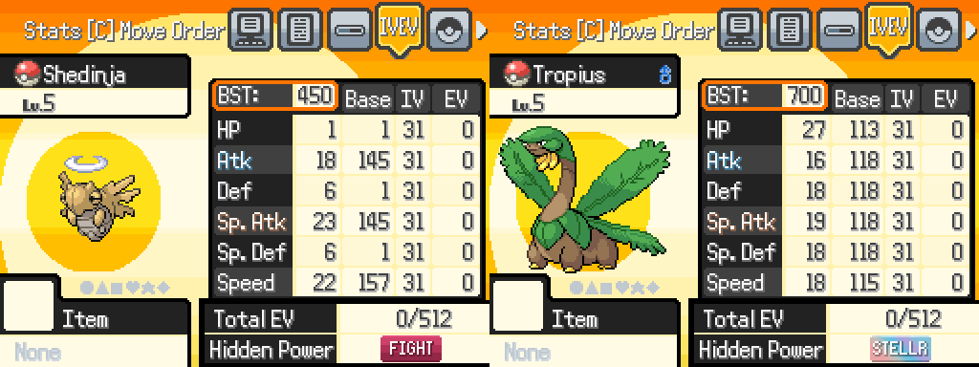
The third and fourth special case Pokémon Family Lines (Tropius is simply a Pokémon I like, and it’s a real shame they are not good in higher tiers. Shedinja can learn the strongest Abilities outside of Wonder Guard, such as Good as Gold and Unseen Fist. You must Mega Evolve Pokémon such as Meowth for Good as Gold, and Marshadow for Unseen Fist. Shedinja is forced to be Tera Stellar, to snuff out Air Balloon + Tera Electric)

1 out of 6 Abilities, no Multi Innates like Elite Redex
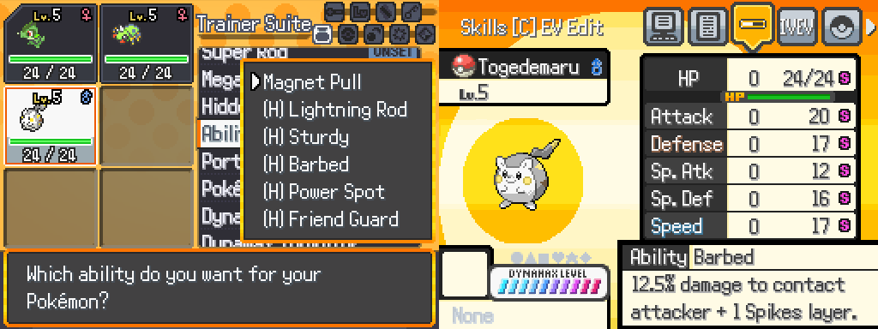
Nearly every Pokémon can freely choose 1 out of 6 Abilities. As many existing Abilities as possible have been tweaked or overhauled to be more usable in Battle.
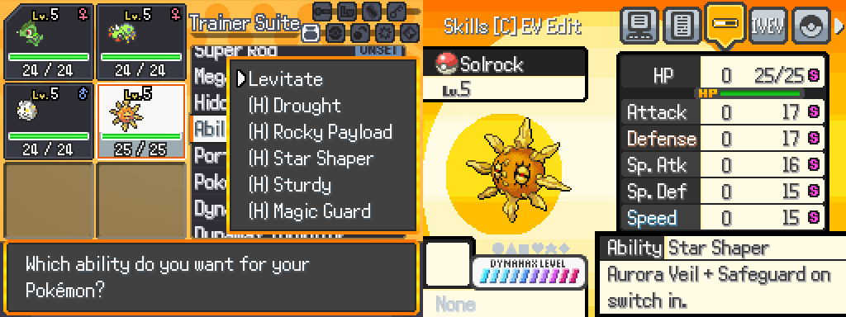
Pickup removes Non-Sticky Hazards on Switch-In, Shadow Tag can only trap Psychic Type Pokémon, Illuminate boosts Accuracy 30%, and weakens Dark Type Moves by 50%, Run Away gives +2 Speed if any Stat is lowered, Rocky Payload sets Stealth Rock on Contact and gives Rock Type STAB, etc.
The entire Movepool history, all 987 Moves
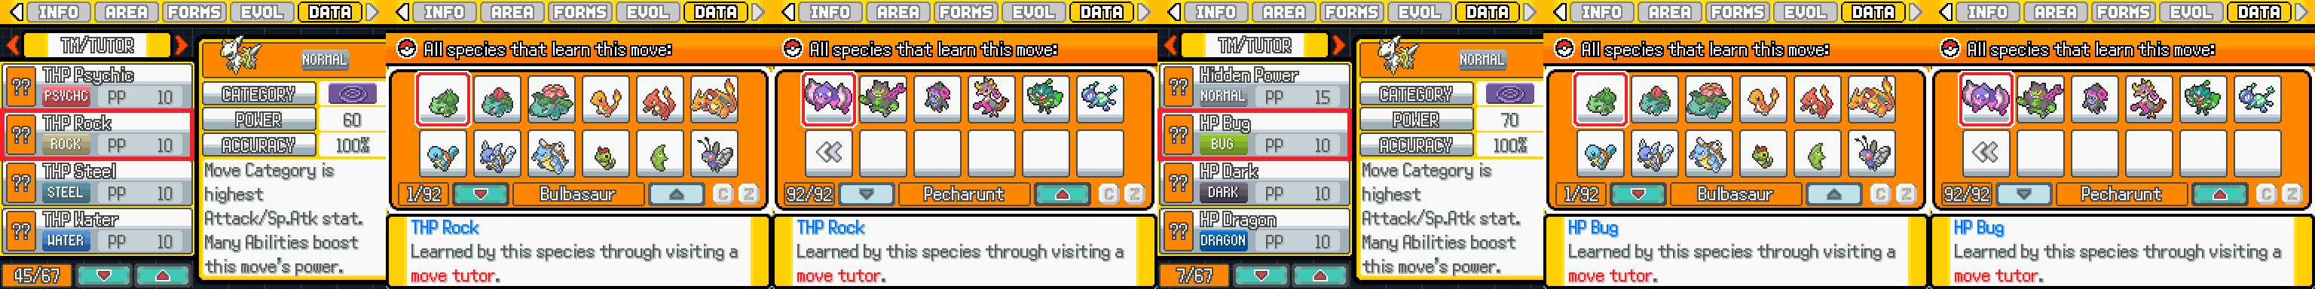
Decades has almost the entire history of every Move that has existed in Pokémon, Gen 1 to Gen 9. All deleted moves starting in Gen 8 are back, including Hidden Power. Nearly every one of the 900+ Moves have been tweaked, overhauled or transformed to make every Pokémon have a wider and deeper selection of strategies to use.
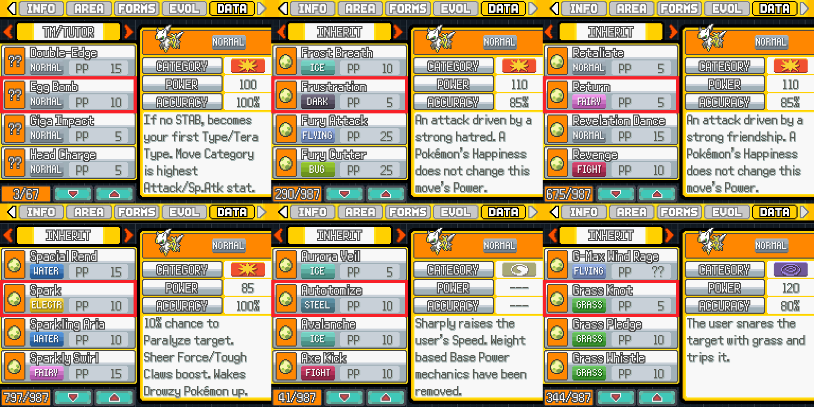
Chilly Reception is now a -1 Speed Ice Type Parting Shot. Arm Thrust is Fighting Type Dual Chop, because of Pound, renamed to Pummel, and is a Universal Fighting Type Move, is Fighting Type Tail Slap. Astonish is Ghost Type Fake Out. Astral Barrage is now a 95 Base Power, 90% Accurate move, because it’s now a universal Ghost Type Move, just like Heat Wave. There are dedicated Technician 60 Base Power Hidden Power Moves, and dedicated 70 Base Power Hidden Power Moves, that are also boosted by every Power Enhancing Ability, such as Strong Jaw, Sharpness, Sheer Force, Iron Fist, Mega Launcher, Big Pecks and Tough Claws. So on and so on, for every one of the 18 Move Types, etc.
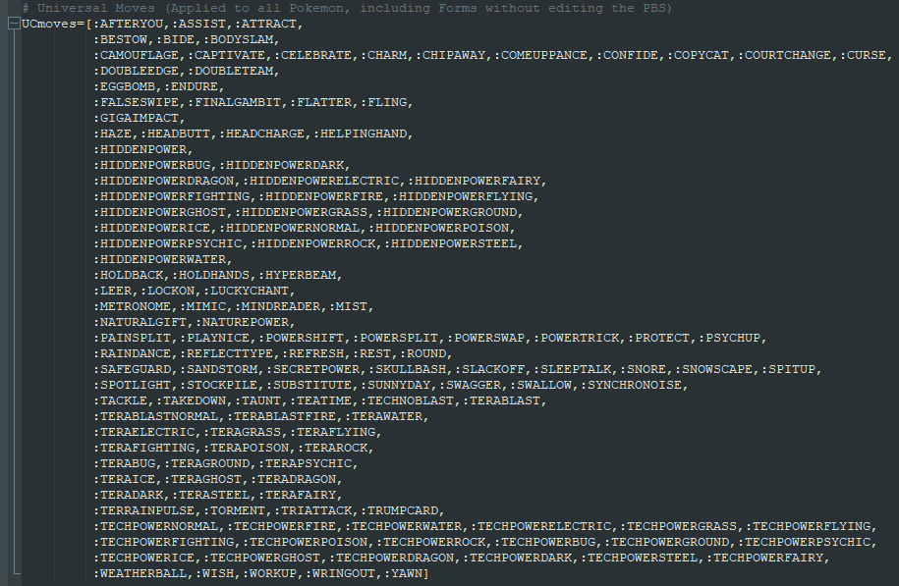
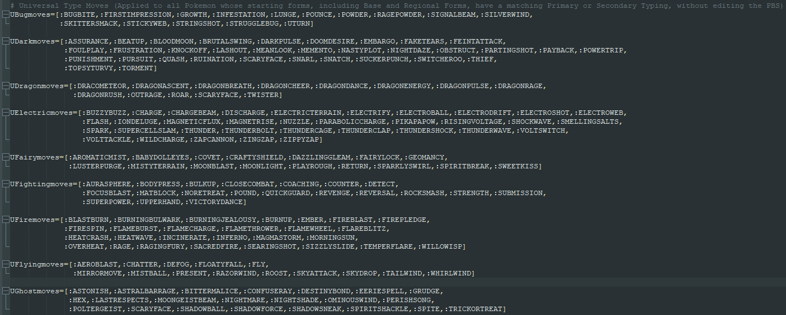
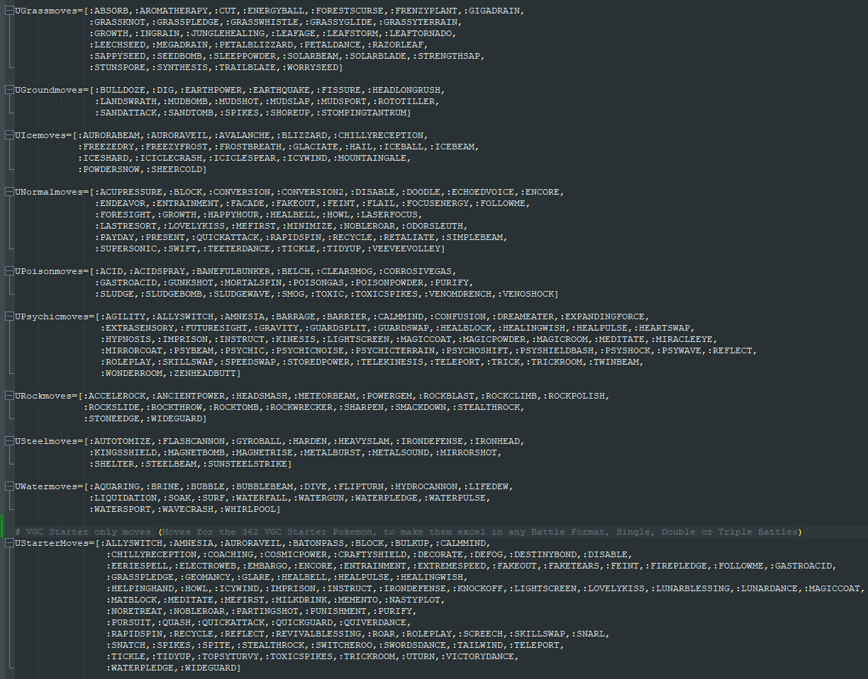
Via Ultimate Move Tutor, every Pokémon has access to Universal Moves, and Universal Move Types.
Flexibly swap around the Decades and Vanilla Gen 9 Metagame
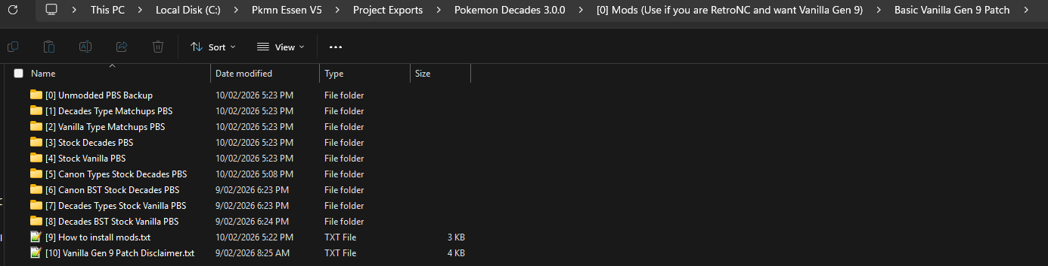
If you just want the Vanilla Gen 9 Metagame, the Basic Vanilla Gen 9 Patch can be used. But read the disclaimer that comes with the patch, to know what the patches cannot change or revert. Simply put, once you use the patch, you have chosen not to play Decades in the intended way it was designed.

Time Respecting IV/EV Training
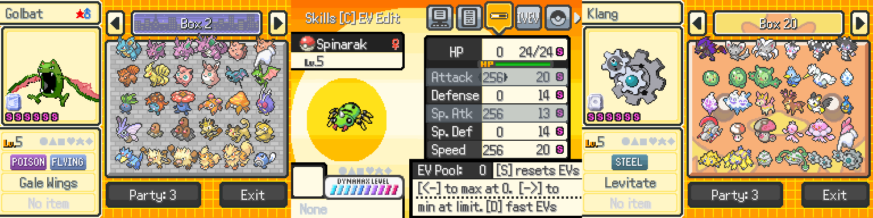
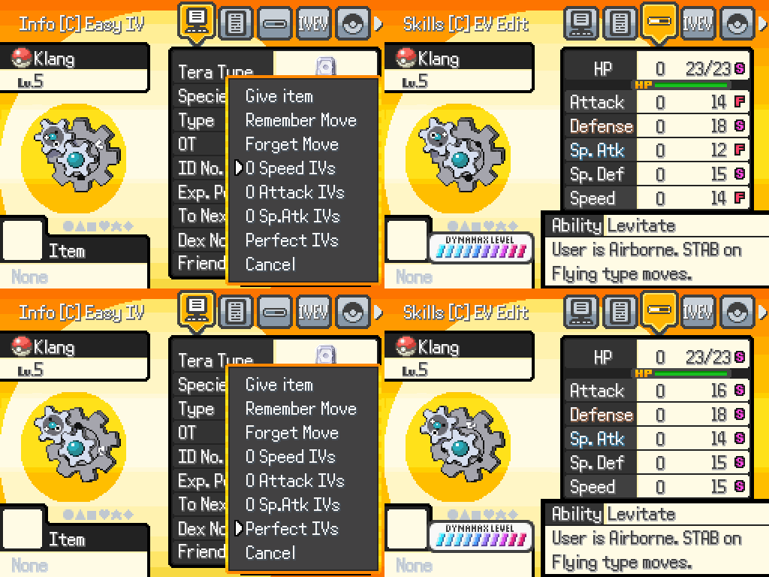
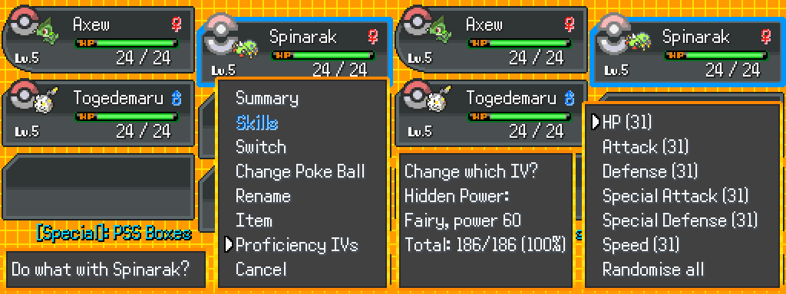
Every Pokémon generated in-game will always have perfect 31 IV’s. As listed in the Quality of Life Features, you can freely tweak EV’s and IV’s to your heart’s content, zero grinding required, including precise IV’s for Beast Boost/Proficiency and Trick Room Speed Tiers.
Paralysis will never have a chance to paralyze; it can only reduce Speed. Frostbite replaces Freeze. Drowsy replaces Sleep. Hailstorm combines Snow and Hail. The details of these changes can be read in the Adventure Guide. Due to the nature of as much documentation as possible being accessible in-game, on top of the countless changes to under the hood mechanics, Decades does not have a Damage Calculator, and its design has no interest in facilitating Challenge Runs, such as Nuzlockes. There will never be an online wiki for Decades, because I will not be capable of maintaining a niche resource on my own.
Choose Your First Partner/Starter Pokémon
Decades provides you with 5 dedicated options for choosing your Starter Pokémon. From these options, you can choose from over 547 Pokémon to be your Starter, consisting of every First Stage Pokémon in every Evolution Family Line.
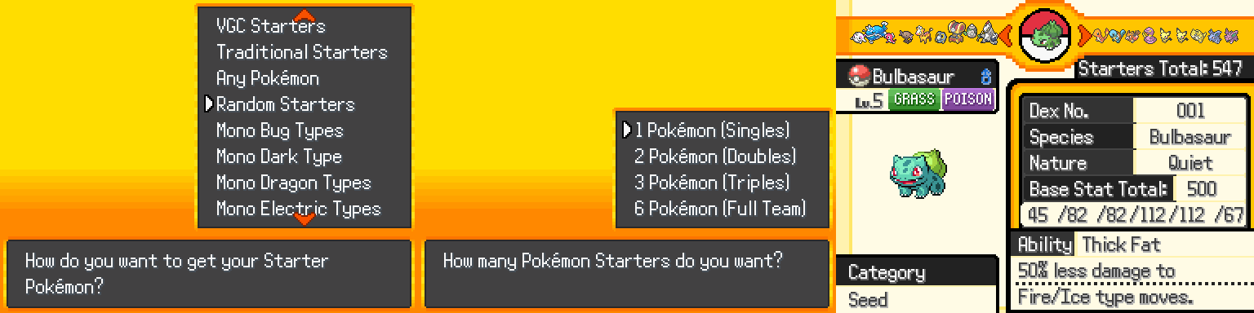
VGC Starters, (362 Choices, intended batch of Starters) Traditional Starters, (60 Choices) Any Pokémon, (547 Choices) Random Starters, (Randomized Choices, can be any Pokémon) and Monotype Choices (Consists of every Pokémon that is or becomes a specific Monotype, through Evolution or Form/Forme via the Form Trader. You obtain your Starter, the second you click New Game, and before you reach the International Airport. Starter choices do not change for any of the options when using the Basic Vanilla Gen 9 Patch)
Who Decades appeals to
Decades will appeal to you if you like the following Pokémon Fan Games:
Tectonic
Elite Redux/Radical Red
Unbound
Reborn/Rejuvenation
Compact
Eon Guardians
Drayno’s Rom Hacks
ROWE
Decades took most of its notes from Tectonic, Compact and Elite Redex. Broadly, if you enjoy fan games where you can unconditionally use every Pokémon, and experiment with the Metagame Sandbox, with the entire history of Pokémon’s Metagame mechanics, you will be in for a good time.
Trailer/Playthroughs/Coverage
Trailer Pending…
Developer Playthrough Pending…
Promote my Shit YouTubers/Streamers…
Changelog
Version 3.0.0: Game Release, debuted 100% finished, for both Story and Battle Mode
Patches Log: Pending…
Credits
Pending… (To be included in a Code Window, due to the volume)
Download
Mega: https://mega.nz/folder/4nczHZhL#UJLm3jf1lMLheJAGpivKZA
Mediafire:
Google Drive:
Github:
Pokémon Decades 3.0.0 is a fully finished fangame, with roughly 20 hours of playtime for Story Mode. Battle Mode is an extreme variation of playtime and depends on your interest in Pokémon Metagame battles.
Pokémon Decades Developer Team
It's just me, Hazy Crazy. Aka, 4AllNighterGrinder64 (Eevee Expo) or OgreDevil632 (Poke Community)
Outside of the public resources used from Eevee Expo and Poke Community, Pokémon Decades was a project that began on the 31^{st of} May 2025 and reached it’s finished playable Beta on the 10^{th of} February 2026. Making the development of the finished game take over 8 months, not counting the time to get Decades ready for its release and promoting the game. I do not claim ownership over any franchise or its associated content. All original characters, artwork and other media remain the property of their respective authors.
Please support the official releases. And I do not care if you glaze the game, (do not be a shill, shit on the game if it’s got a problem) or hate it/me with every fiber of your body. (Wow, you want me to kill myself. You will never be a professional hater like Hayao Miyazaki. You’re not even 0.1% of a Low Tier God.) I’m going back to original video game projects now. I hope I have proved to you, RetroNC, that I did all I could to apply your feedback.
https://www.youtube.com/watch?v=czDHk62YtWc&t=827s
(12:35)

